**Project Team 27**

Sprint #2

Week #4

Team Member Name – Swapnil Makarand Joshi

What I did since the last week scrum?

1. Finish Development and behavior/working of GUI element
2. Completed integration and testing

What I plan to do next week?

None

What blockers I have?

None

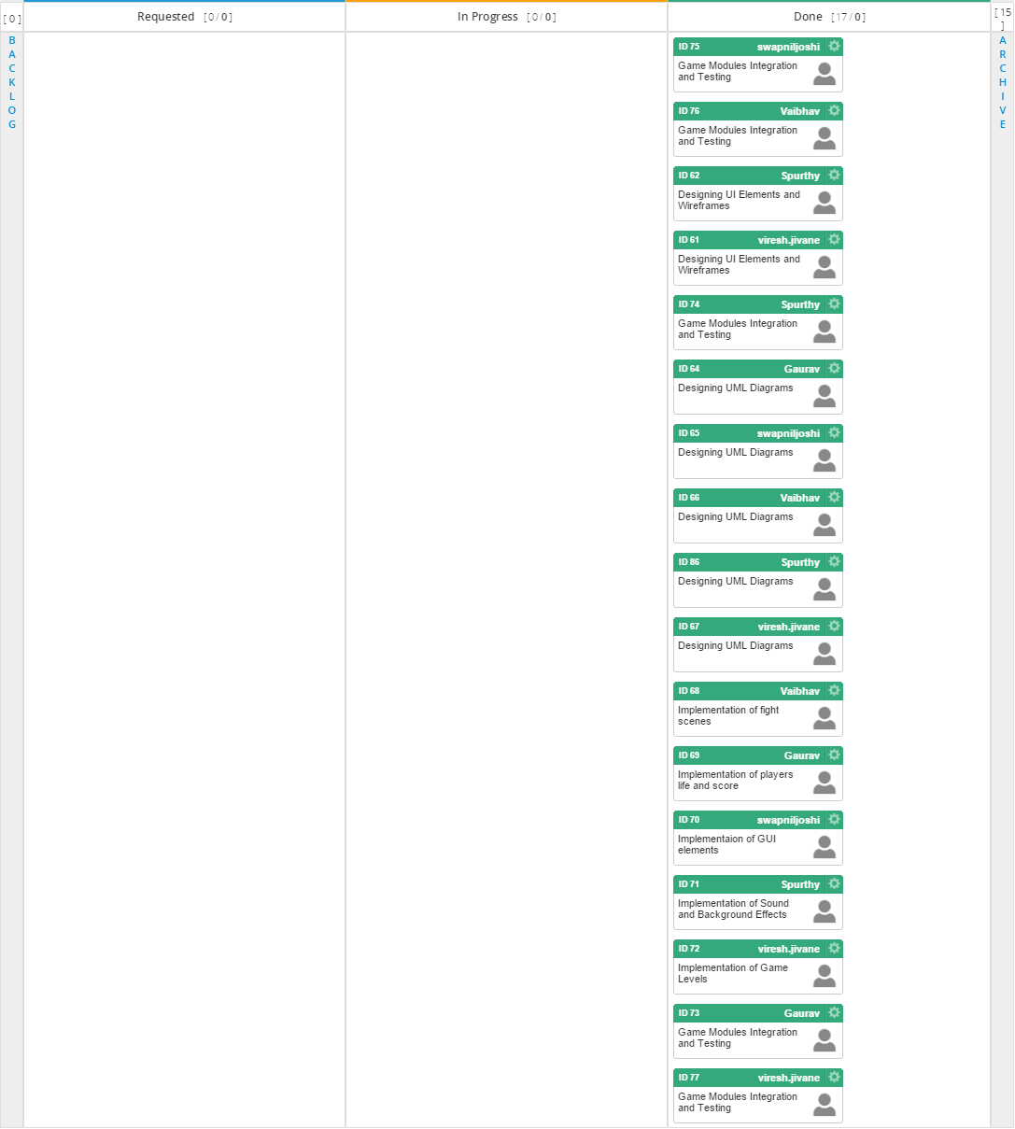

Task board in Kanbanize

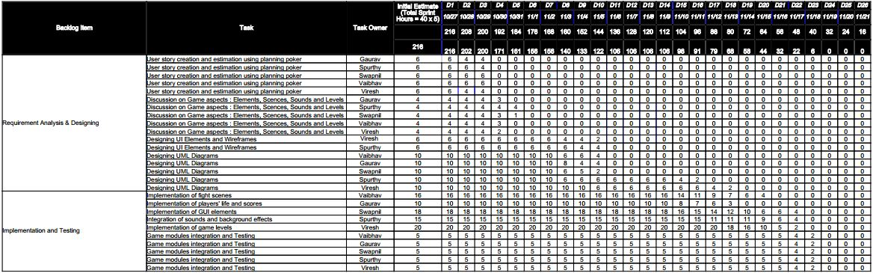

Weekly Standup Report

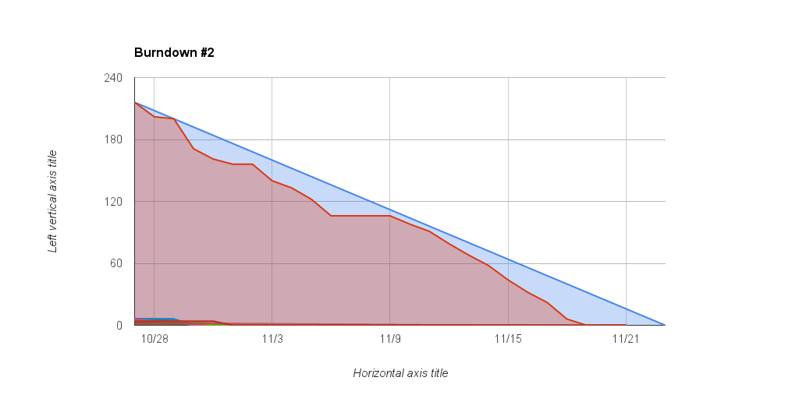

Burndown Chart